# Sign In and Connect to Linux server on AWS
Step 1:
Open AWS account and Sign In to console
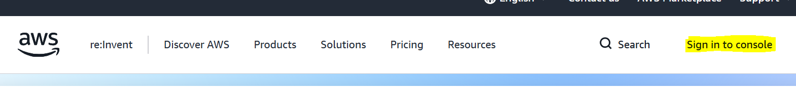
Step 2:
Sign In through root user email. On next page enter email Id and password then Sign In to AWS Console as shown below.
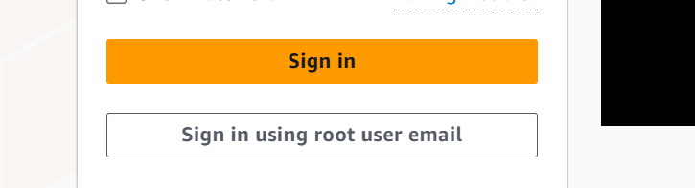
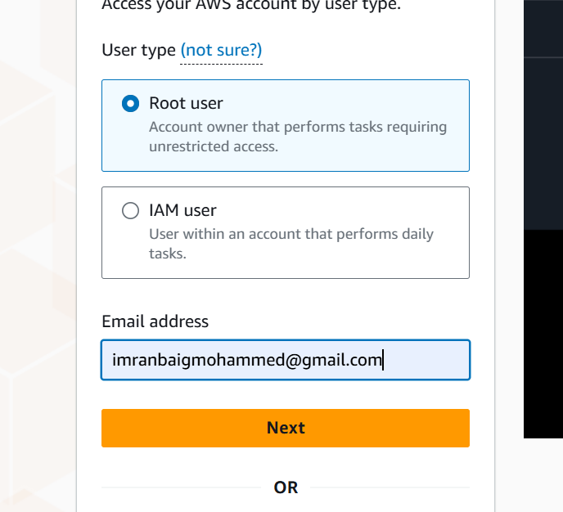
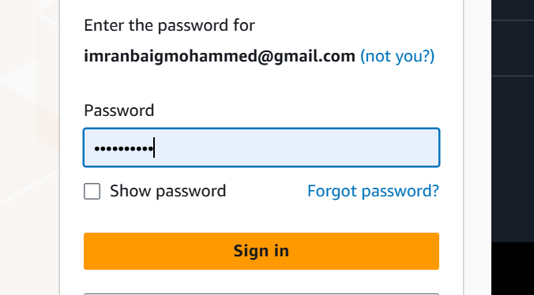

Step 3:
Click on three lines of left side corner and select All services and then click EC2
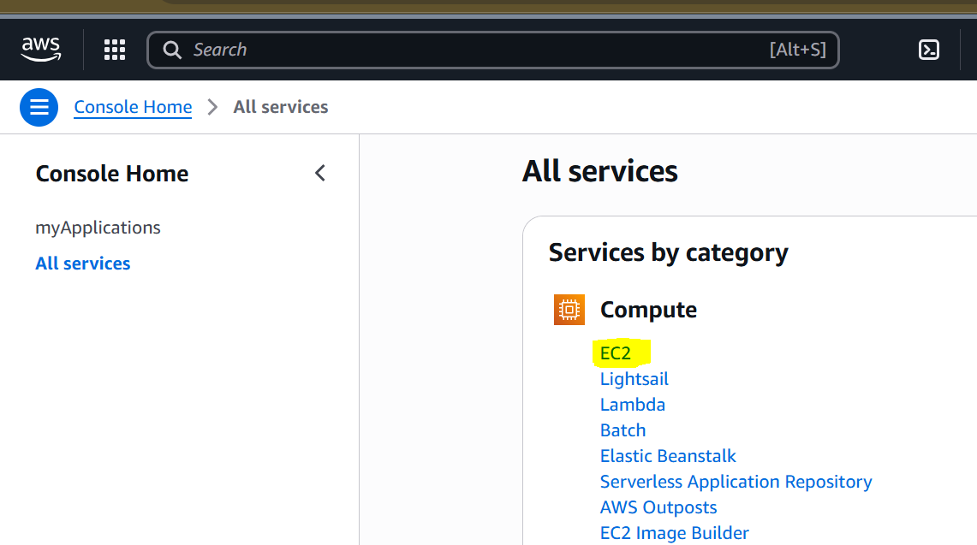

Step 4:
After clicking EC2 we see the dashboard of EC2. Then we need to click Instance on the left side corner.
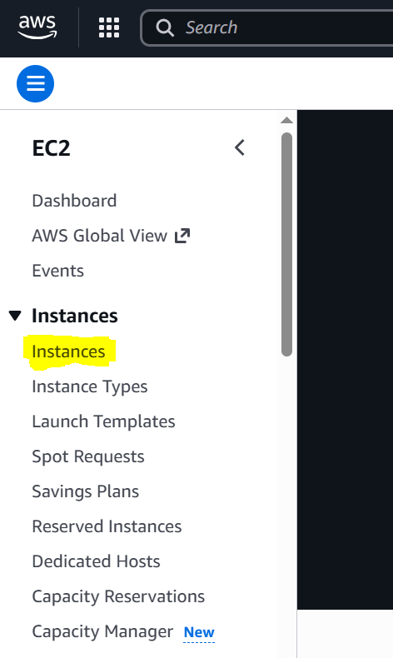

Step 5:
After Instance open, click on Launch Instance.
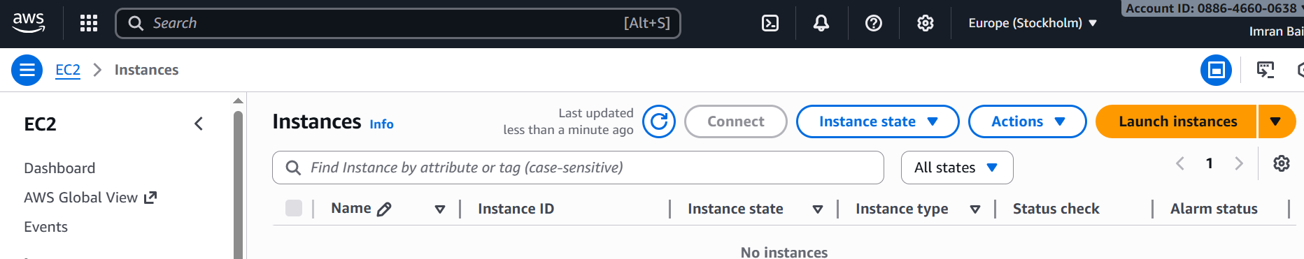

Step 6:
After clicking launching Instance, we get a page as shown below.
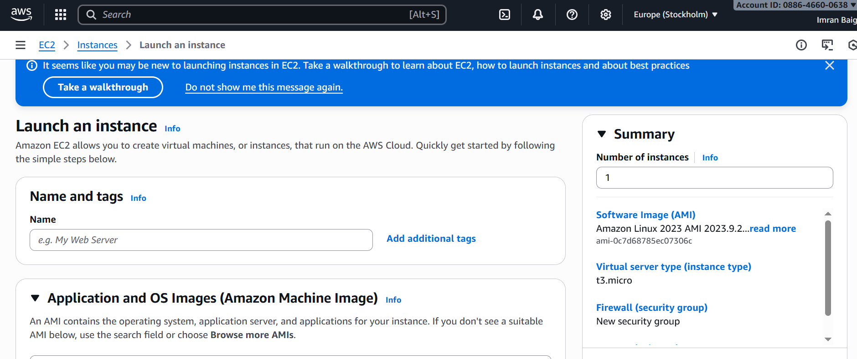

Step 7:
First we need to give name to a web server as shown below. Here I gave name as a Demo to a web server.
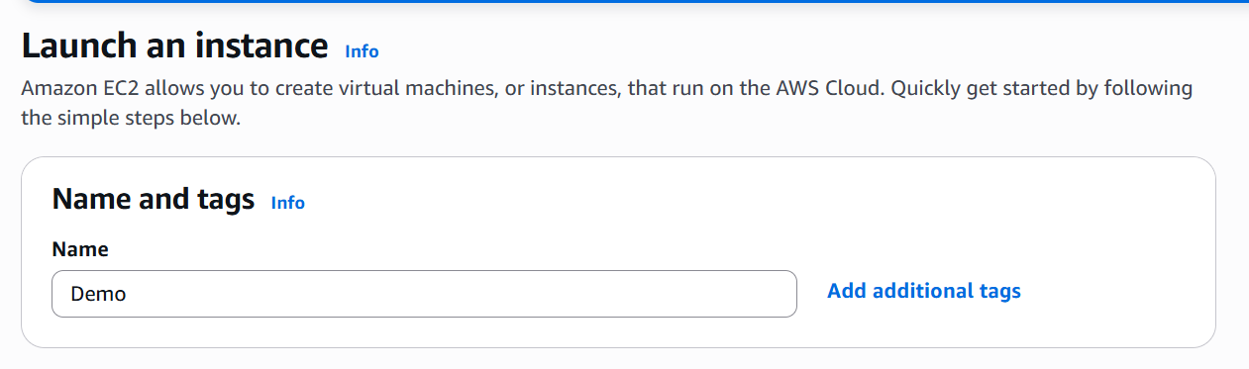

Step 8:
Then we need to select OS for our server. Here I select Ubuntu OS as it is easy to use for our server.
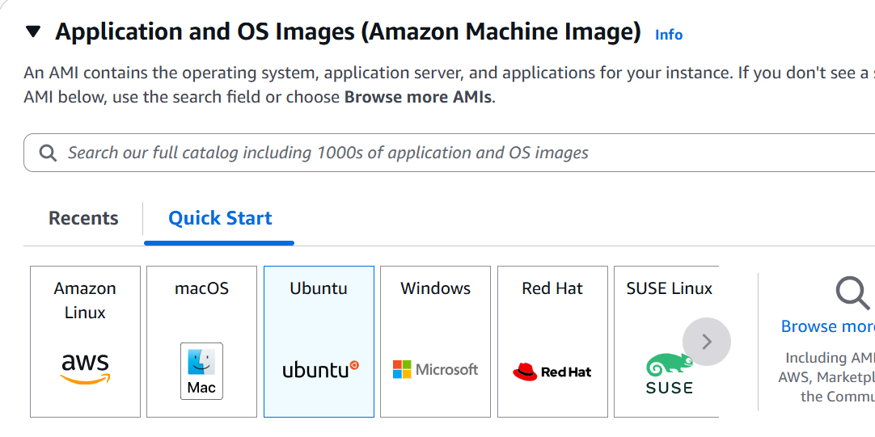

Step 9:
Here we need to select instance type and I’m selecting free tier eligible as shown below
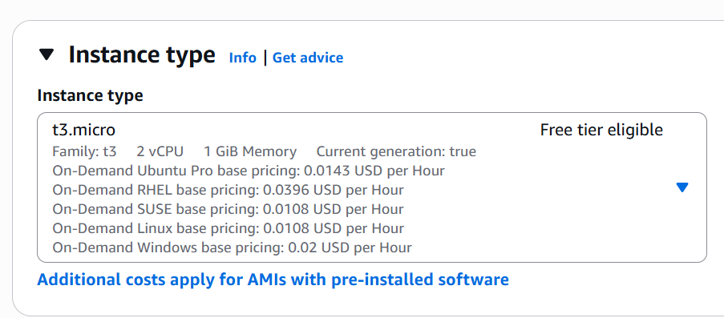
Step 10:
Create key pair login as shown below so that it will be connected to local server
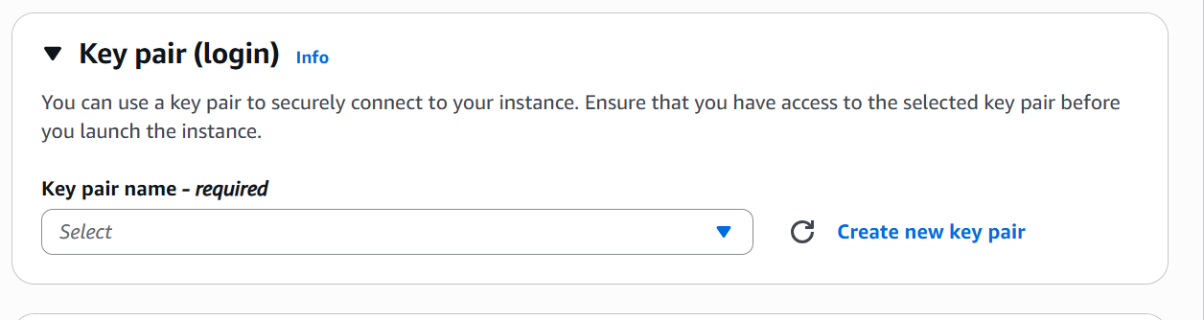
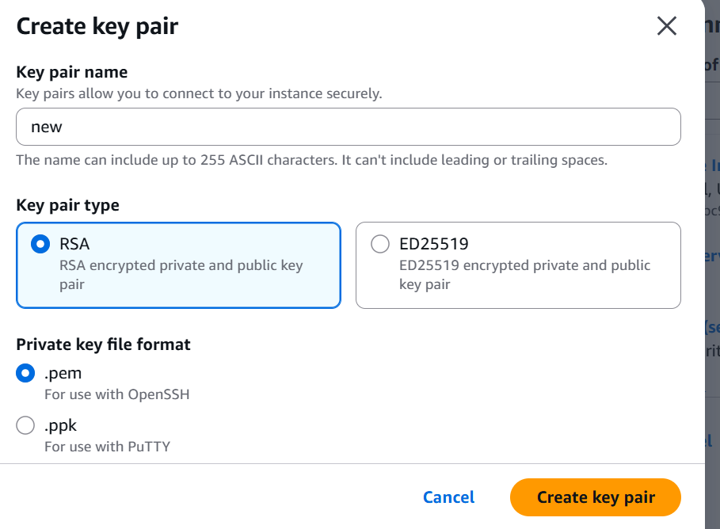
Step 11:
Setup Network settings and keep it as it is default given in system as shown below
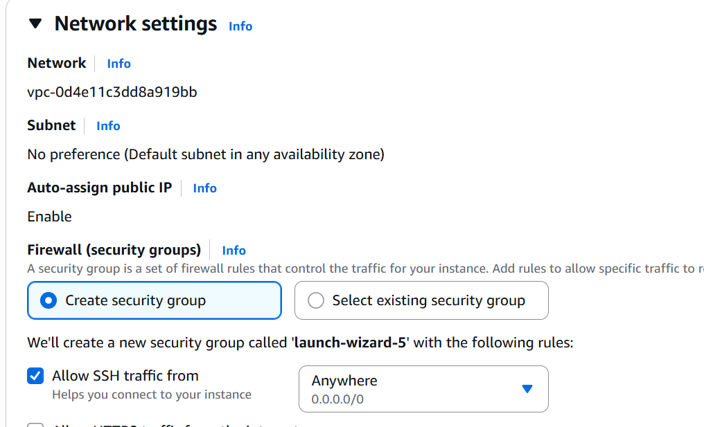

Step 12:
We need to configure storage how much we want for server. Here I’m going with system default storage as shown below
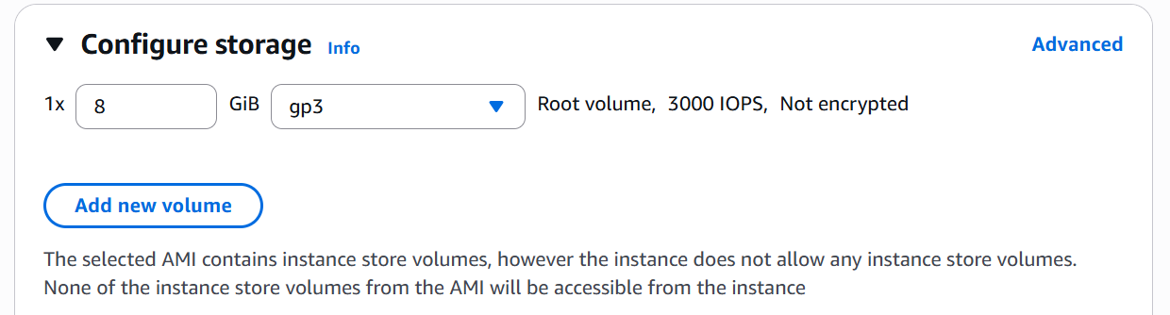

Step 13:
After giving all the information in right side of the dashboard summary will be there we need to check before launching instance.
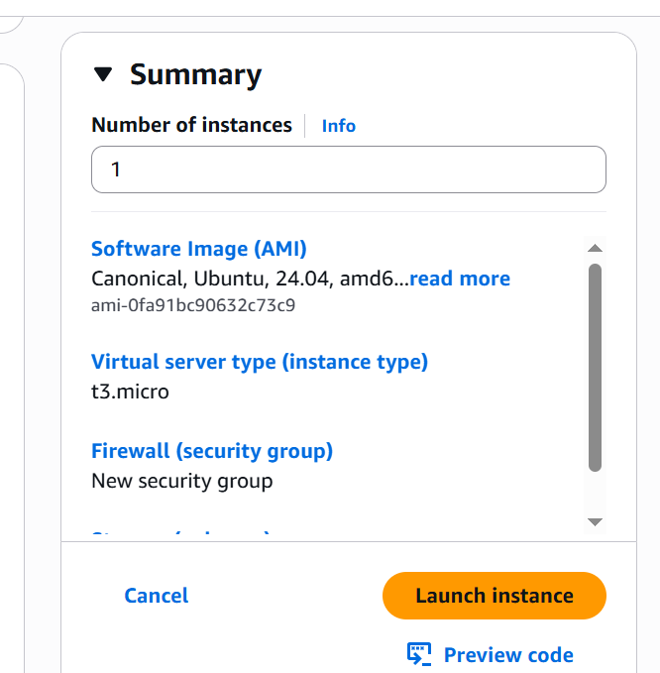

Step 14:
After thoroughly checking the summary we should launch instance and it will appear as shown in below picture.
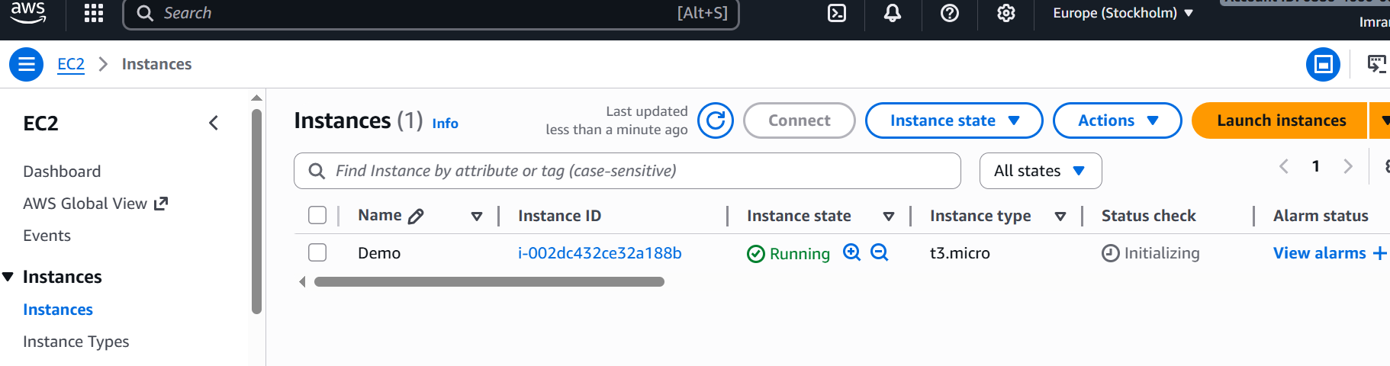

Step 15:
Till before step we launched instance and now we should connect to the terminal
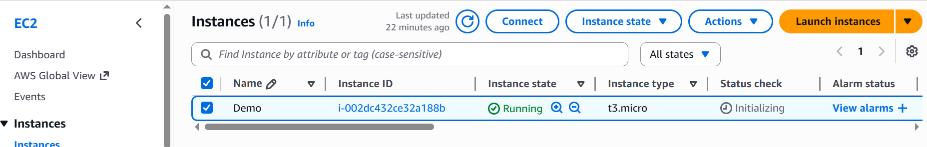

Step 16:
When we connect, the page shown below appears and we need to copy the server connection link shown in example.
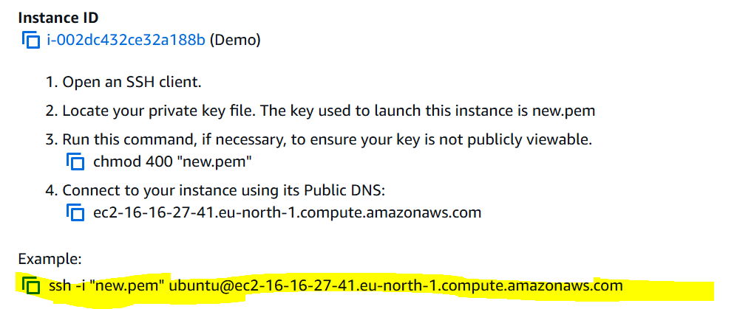
Step 17:
We should open Powershell terminal in our system as shown below.
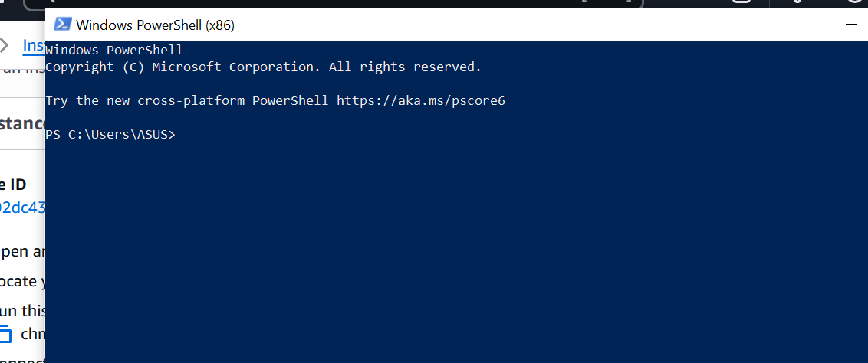

Step 18:
First we need to navigate to where our key pair file .pem located. It stored in downloads, so we should navigate to downloads through terminal as shown below
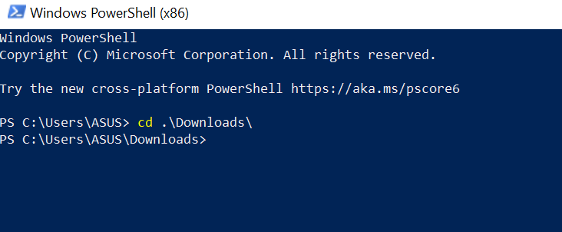

Step 19:
Paste the server link command in terminal and hit enter, It will ask for permission to enter into terminal there we need to give Yes as shown below
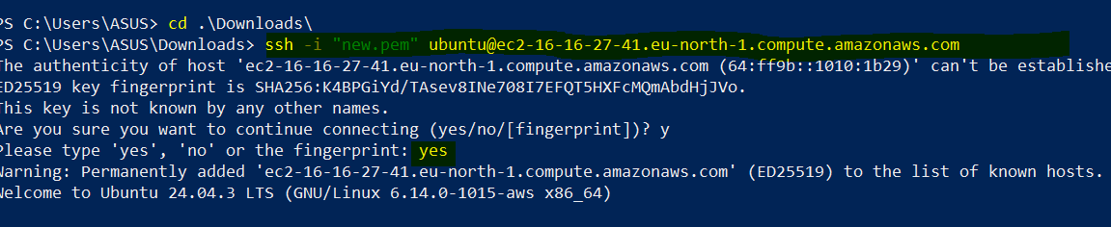
Step 20:
Finally the Powershell terminal is connected to AWS Server.
